**Name-TASMIYA FATHIMA**

**USN-1BM19CS172**

**Write program to obtain the Topological ordering of vertices in a given digraph.**

**Modification- DFS/Source Removal method**

**1)DFS**

//DFS

#include<stdio.h>

#include<stdlib.h>

int a[10][10],n,indegre[10];

void find_indegre()

{ int j,i,sum;

for(j=0;j<n;j++)

{

sum=0;

for(i=0;i<n;i++)

sum+=a[i][j];

indegre[j]=sum;

}

}

void topology()

{

int i,u,v,t[10],s[10],top=-1,k=0;

find_indegre();

for(i=0;i<n;i++)

{

if(indegre[i]==0) s[++top]=i;

}

while(top!=-1)

{

u=s[top--];

t[k++]=u;

for(v=0;v<n;v++)

{

if(a[u][v]==1)

{

indegre[v]--;

if(indegre[v]==0) s[++top]=v;

}

}

}

printf("The topological Sequence is:\n");

for(i=0;i<n;i++)

printf("%d ",(t[i]+1));

}

void main()

{

int i,j;

printf("Enter number of vertices:");

scanf("%d",&n);

printf("\nEnter the adjacency matrix:\n");

for(i=0;i<n;i++)

{

for(j=0;j<n;j++)

scanf("%d",&a[i][j]);

}

topology();

}

**Output:**

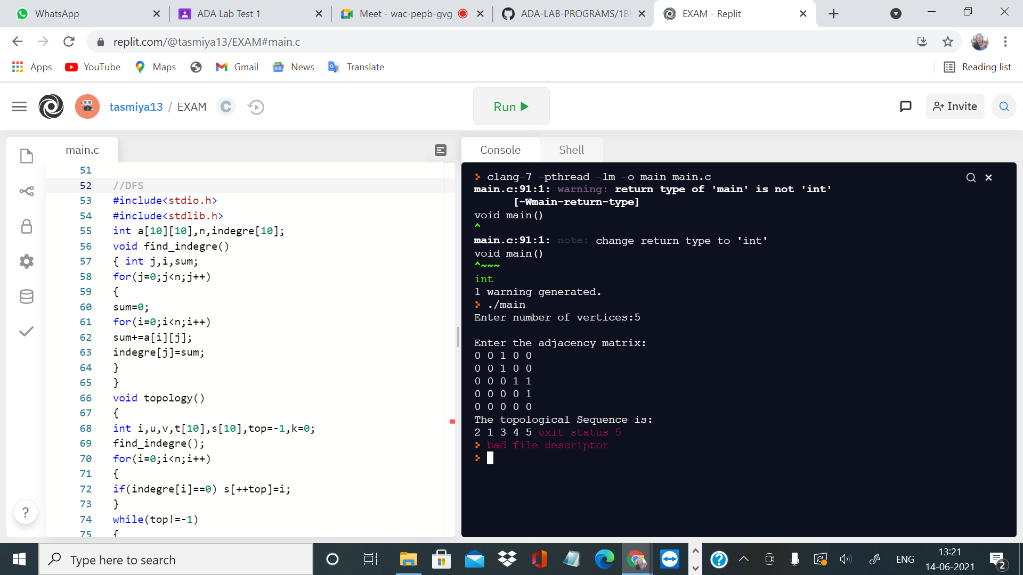

**Modification(Source Removal)**

#include<stdio.h>

int temp[10],k=0;

void topo(int n,int indegree[10],int a[10][10])

{

int i,j;

for(i=1;i<=n;i++)

{

if(indegree[i]==0)

{

indegree[i]=1;

temp[++k]=i;

for(j=1;j<=n;j++)

{

if(a[i][j]==1&&indegree[j]!=-1)

indegree[j]--;

}

i=0;

}

}

}

int main()

{

int i,j,n,indegree[10],a[10][10];

printf("enter the number of vertices:");

scanf("%d",&n);

for(i=1;i<=n;i++)

indegree[i]=0;

printf("\n enter the adjacency matrix\n");

for(i=1;i<=n;i++)

for(j=1;j<=n;j++)

{

scanf("%d",&a[i][j]);

if(a[i][j]==1)

indegree[j]++;

}

topo(n,indegree,a);

if(k!=n)

printf("topological ordering is not possible\n");

else

{

printf("\n topological ordering is :\n");

for(i=1;i<=k;i++)

printf("v%d\t",temp[i]);

}

}

**Output-**

